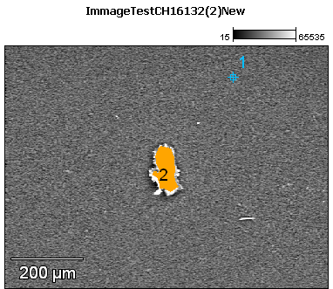

Image Name: ImmageTestCH16132(2)New

Image Resolution: 512 by 384

Image Pixel Size: 1.77 µm

Acc. Voltage: 17.0 kV

Magnification: 140

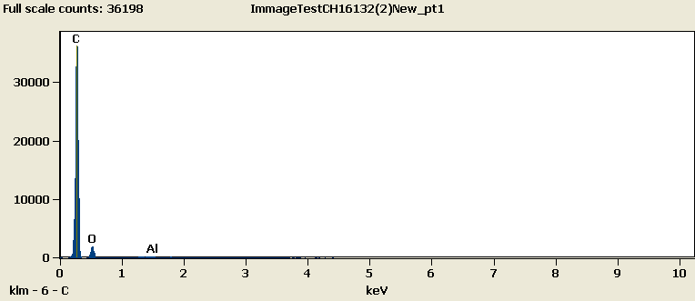

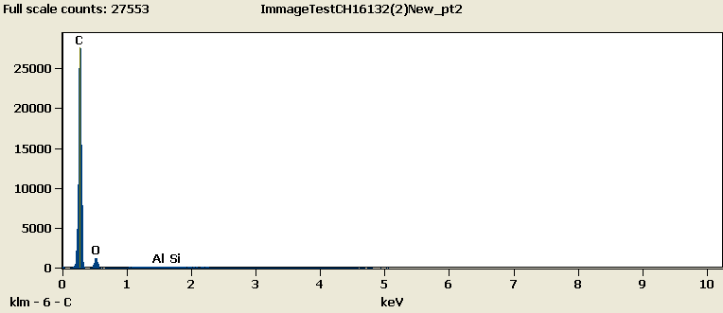

Weight %

|  |  |  |  |  |
| --- | --- | --- | --- | --- |
|  | ***C-K*** | ***O-K*** | ***Al-K*** | ***Si-K*** |
| ***ImmageTestCH16132(2)New_pt1*** | 90.50 | 9.40 | 0.10 |  |
| ***ImmageTestCH16132(2)New_pt2*** | 91.83 | 7.97 | 0.10 | 0.09 |

Weight % Error (+/- 1 Sigma)

|  |  |  |  |  |
| --- | --- | --- | --- | --- |
|  | ***C-K*** | ***O-K*** | ***Al-K*** | ***Si-K*** |
| ***ImmageTestCH16132(2)New_pt1*** | ±0.26 | ±0.26 | ±0.01 |  |
| ***ImmageTestCH16132(2)New_pt2*** | ±0.28 | ±0.29 | ±0.02 | ±0.02 |

# Cations

|  |  |  |  |  |
| --- | --- | --- | --- | --- |
|  | ***C-K*** | ***O-K*** | ***Al-K*** | ***Si-K*** |
| ***ImmageTestCH16132(2)New_pt1*** | 0.00 | 0.00 | 0.00 |  |
| ***ImmageTestCH16132(2)New_pt2*** | 0.00 | 0.00 | 0.00 | 0.00 |